**Project Report Template**

Introduction:

1.1 Overview:

* The main goal of the new coalition is to offer a strong challenge to the ruling BJP. The coalition wants to bring together India is various regional parties so they may stand against the BJP as one.
* To promote secularism and Religion tolerance. The coalition is committed to protecting the rights of all religious minorities in Indians.

1.2 Purpose:

* To strengthen the federal system of government. The coalition believes that the BJP has been centralizing power in the hands of the central government, and that this is leading to decline in democracy.
* To improve the lives of ordinary Indians. The coalition is committed to addressing the issues of poverty, unemployment, and inequality.

PROBLEM DEFINITION AND DESIGN THINKING:

2.1 Empathy Map:

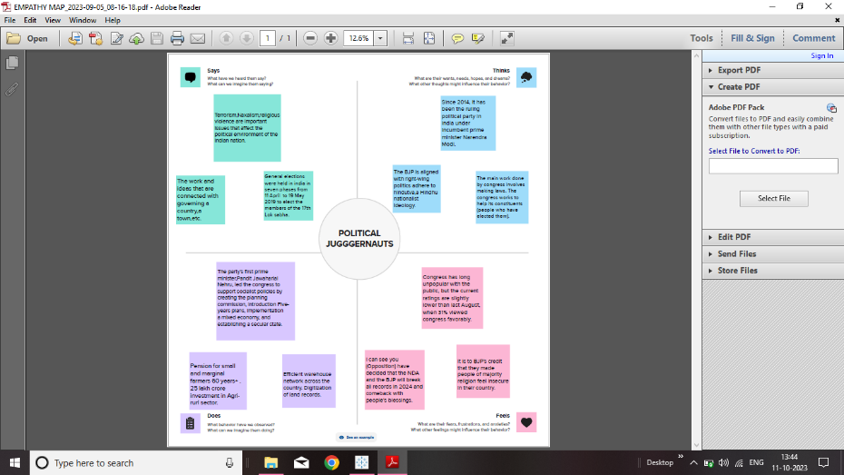

2.2 Ideation & Brain Storming Map:

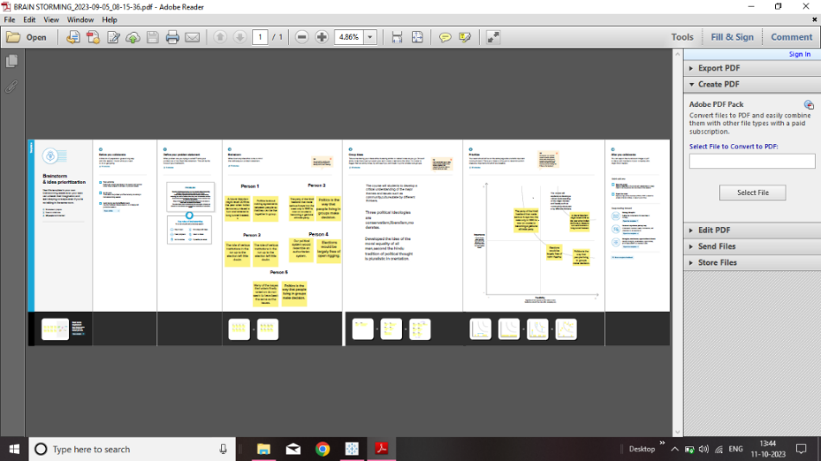

RESULT:



ADVANTAGES & DISADVANTAGES

1. ADVANTAGES:

* It tells in proper functioning of democracy through the system of checks and balances.
* It controls the despotism of the government.
* It’s the supreme laws making body of the country.
* A money bill can only be introduced the Lok Sabha.

1. DISADVANTAGES:

* To implement one nation, one election changes would also be required in the constitution and other legal frame works.
* Would need a constitutional amendment and then it would need to be taken to state assemblies.
* Lok Sabha speak about problems of people.

APPLICATIONS:

* The Lok Sabha has certain powers that make it more powerful than the Rajya Sabha.
* Motions of no confidence against the government can be introduced and passed in the Lok Sabha.
* It helps in proper functioning of democracy through the system of checks.

CONCLUSION:

* The Lok Sabha is more powerful than the Rajya Sabha is almost all matter.
* General elections were held in India in seven phases from 11 April to 19 May 2019 to elect the members of the 17th Lok Sabha. Votes were counted and the result was declared on 23 May.
* The election resulted in a landslide victory for the BJP which won 303 sets and formed the government.

FUTURE SCOPE:

* Preparing for the 2024 general election, the Indian government is actively crafting a comprehensive strategic plan to introduce a series of sops and incentives.
* Law commission has informed that they are working on synchronising all assembly polls with Lok Sabha polls from 2029 onwards to facilitate the one nation one election or simultaneous polls process in India.
* India, it would appear, is in perpetual election mode. Every state assembly election, analysts believe, will tell us about the mood of the people as the country moves towards the big one-the Lok Sabha elections in 2024.